**How HashMap works in Java**

HashMap works on the principle of Hashing .  To understand Hashing , we should understand the three terms first   i.e  *Hash Function , Hash Value and Bucket .*

**What is Hash Function , Hash Value  and Bucket ?**

hashCode() function  which returns an integer value is the **Hash function**. The important point to note that ,  this method is present in Object class ( Mother of all class ) .

This is the code for the hash function(also known as hashCode method) in Object Class :  
  
    **public native int hashCode();**

The most important point to note from the above line :  hashCode method return  int value .

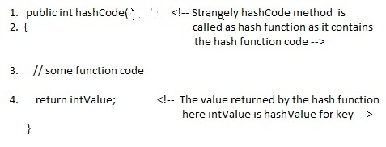

**What is bucket ?**   
A bucket is used to store key value pairs . A bucket can have multiple key-value pairs . In hash map, bucket used simple linked list to store objects .

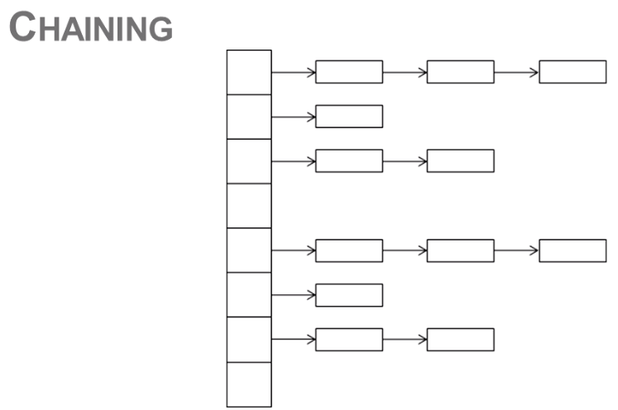

***How HashMap works in java or How get() works internally in java .***

